Chapter 1
Introduction to Database Systems
Contents

• Basic Definitions
• Typical DBMS Functionality
• Example of a Database (UNIVERSITY)
• Main Characteristics of the Database Approach • Database Users
• Data Models
• Schemas and Instances
• Three-schema Architecture and Data Independence
• Database Languages and Interfaces • The Database System Environment.

Basic Definitions

• Database:
– A collection of related data. • Data:
– Known facts that can be recorded and have an implicit meaning.
• Mini-world:
– Some part of the real world about which data is stored in a database. For example, student grades and transcripts at a university.
• Database Management System (DBMS):
– A software package/ system to facilitate the creation and maintenance of a computerized database.
• Database System:
– The DBMS software together with the data itself. Sometimes, the applications are also included.

Problems with traditional approach

• Inconsistency
• Redundancy
• Loss of flexibility
• Multiple files
• Update Problem
Types of Databases and Database Applications

• Traditional Applications:
– Numeric and Textual Databases
• More Recent Applications:
– Multimedia Databases
– Geographic Information Systems (GIS) – Data Warehouses
– Real-time and Active Databases – Many other applications
Typical DBMS Functionality

• Define a particular database in terms of its data types, structures, and constraints

• Construct or Load the initial database contents on a secondary storage medium

• Manipulating the database:
– Retrieval: Querying, generating reports
– Modification: Insertions, deletions and updates to its content – Accessing the database through Web applications
• Processing and Sharing by a set of concurrent users and application programs – yet, keeping all data valid and consistent
• Other features:
– Protection or Security measures to prevent unauthorized access

– Presentation and Visualization of data
– Maintaining the database and associated programs over the lifetime of the database application

• Called database, software, and system maintenance

Simplified database system environment

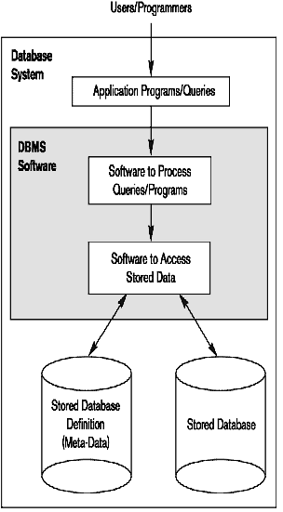

Example of a Database (with a Conceptual Data Model)

• Mini-world for the example:
– Part of a UNIVERSITY environment.
• Some mini-world entities:
– STUDENTs – COURSEs
– SECTIONs (of COURSEs)
– (academic) DEPARTMENTs
– INSTRUCTORs
• Some mini-world relationships:
– SECTIONs are of specific COURSEs
– STUDENTs belong to SECTIONs
– COURSEs have prerequisite COURSEs
– INSTRUCTORs teach SECTIONs
– COURSEs are offered by DEPARTMENTs
– STUDENTs major in DEPARTMENTs

Main Characteristics of the Database Approach

• Self-describing nature of a database system:
– A DBMS catalog stores the description of a particular database (e.g. data structures, types, and constraints)

– The description is called meta-data. This allows the DBMS software to work with different database applications such as University DB, Banking DB or Company DB.

• Insulation between programs and data: – Called program-data independence.
– Allows changing data structures and storage organization without having to change the DBMS access programs.

• Data Abstraction:
– The characteristic that allows program-data independence and program-operation independence
• Program-operation independence
– User application programs can operate on the data by invoking operations through their names and arguments, regardless of how the operations are implemented
– A data model is used to hide storage details and present the users with a conceptual view of the database.
– Relational model hides how the data is stored and how the operations are implemented. DB is represented in terms of entities, attributes and relationships among entities that is understood by most users.
– Programs refer to the data model constructs rather than data storage details

• Support of multiple views of the data:
– Each user may see a different view of the database, which describes only the data of interest to that user.

– A DBMS must enforce following transaction properties • Isolation
– Each transaction appears to execute in isolation from other transactions.
• Atomicity
– Either all the database operations in a transaction are executed or none are.
– Concurrency control within the DBMS guarantees that each transaction is correctly executed or aborted
– Recovery subsystem ensures each completed transaction has its effect permanently recorded in the database
– OLTP (Online Transaction Processing) is a major part of database applications. This allows hundreds of concurrent transactions to execute per second.

Database Users

• Users may be divided into
– Those who actually use and control the database content, and those who design, develop and maintain database applications (called “Actors on the Scene”), and

– Those who design and develop the DBMS software and related tools, and the computer systems operators (called “Workers Behind the Scene”).

• Actors on the scene

– Database Administrators:
• Responsible for authorizing access to the database, for coordinating and monitoring its use, acquiring software and hardware resources, controlling its use and monitoring efficiency of operations.
– Database Designers:
• Responsible to define the content, the structure, the constraints, and functions or transactions against the database. They must communicate with the end-users and understand their needs.
– System Analysts and Application Programmers (Software Engineers)
• Familiar with the full range of capabilities provided by the DBMS to accomplish their tasks

4
- Categories of End-users
– End-users: They use the data for queries, reports and some of them update the database content. End-users can be categorized into:
• Casual: access database occasionally when needed
• Naïve or Parametric: they make up a large section of the end-user population.
– They use previously well-defined functions in the form of “canned transactions” against the database.
– Examples are bank-tellers or reservation clerks who do this activity for an entire shift of operations.
• Sophisticated:
– These include business analysts, scientists, engineers, others thoroughly familiar with the system capabilities.
– Many use tools in the form of software packages that work closely with the stored database. – • Stand-alone:
– Mostly maintain personal databases using ready-to-use packaged applications. – An example is a tax program user that creates its own internal database.
– Another example is a user that maintains an address book

Workers behind the Scene

• DBMS System Designers and Implementers
– Design and implement the DBMS modules and interfaces as a software package

– Tool Developers
• Design and implement tools – the software packages that facilitate database modeling and design, database system design, and improved performance
– Operators and Maintenance Personnel
• Responsible for the actual running and maintenance of the hardware and software environment for the database system

Data Models

• Data Abstraction
– Suppression of details of data organization and storage and the highlighting of the essential features for an improved understanding of data
• Data Model:
– A collection of concepts to describe the structure of a database, the operations for manipulating these structures, and certain constraints that the database should obey.
– It provides necessary means to achieve data abstraction •
• Data Model Structure and Constraints:
– Constructs are used to define the database structure
– Constructs typically include elements (and their data types) as well as groups of elements (e.g. entity, record, table), and relationships among such groups
– Constraints specify some restrictions on valid data; these constraints must be enforced at all time.

• Data Model Operations:
– These operations are used for specifying database retrievals and updates by referring to the constructs of the data model.

– Operations on the data model may include basic model operations (e.g. generic insert, delete, update) and user-defined operations (e.g. compute_student_gpa, update_inventory)

Categories of Data Models

• Conceptual (high-level, semantic) data models:
– Provide concepts that are close to the way many users perceive data.

• (Also called entity-based or object-based data models.) • Physical (low-level, internal) data models:
– Provide concepts that describe details of how data is stored in the computer. These are usually specified in an ad-hoc manner through DBMS design and administration manuals
• Implementation (representational) data models:
– Provide concepts that fall between the above two, used by many commercial DBMS implementations (e.g. relational data models used in many commercial systems).

Database Schema

• Database Schema
– The description of a database.
– Includes descriptions of the database structure, data types, and the constraints on the database.

• Schema Diagram
– An illustrative display of (most aspects of) a database schema.

• Schema Construct
– A component of the schema or an object within the schema, e.g., STUDENT, COURSE.

Example of a Database Schema
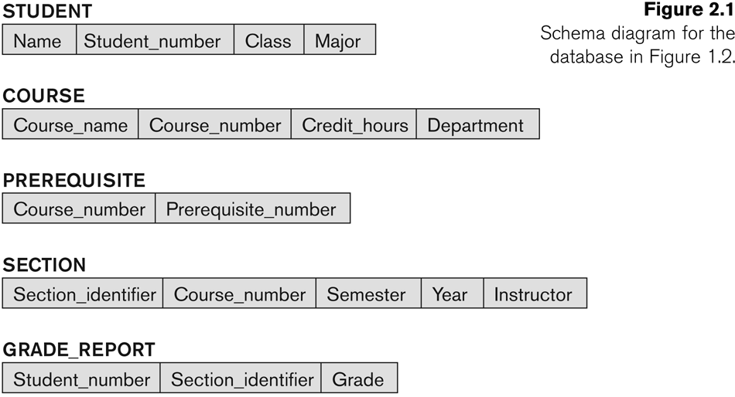

Database State

• Database State
– The actual data stored in a database at a particular moment in time. This includes the collection of all the data in the database.
– Also called database instance (or occurrence or snapshot).
• The term instance is also applied to individual database components, e.g. record instance, table instance, entity instance
• Refers to the content of a database at a moment in time. • Initial Database State
– Refers to the database state when it is initially loaded into the system.
• Valid State
– A state that satisfies the structure and constraints of the database.

DB Schema v/s DB State

• Distinction
– The database schema changes very infrequently.
– The database state changes every time the database is updated.
• Schema is also called intension.
• State is also called extension.

Three-Schema Architecture

• Proposed to support DBMS characteristics of: – Program-data independence.
– Support of multiple views of the data.

• Its goal is to separate the user applications and the physical database.

• Not explicitly used in commercial DBMS products, but has been useful in explaining database system organization

• Defines DBMS schemas at three levels:
– Internal schema at the internal level to describe physical storage structures and access paths (e.g indexes).
• Typically uses a physical data model.
– Conceptual schema at the conceptual level to describe the structure and constraints for the whole database for a community of users. It describes entities, data types, relationships, user operations and constraints.
• Uses a conceptual or an implementation data model.
– External schemas at the external level (or view level) to describe the various user views.
• Usually uses the same data model as the conceptual schema.

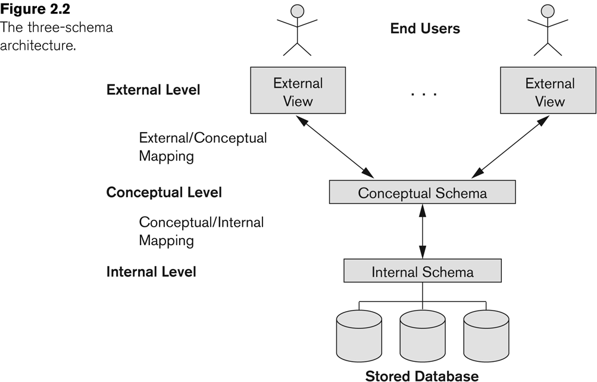
Data Independence

• Logical Data Independence:
– The capacity to change the conceptual schema without having to change the external schemas and their associated application programs.

• Physical Data Independence:
– The capacity to change the internal schema without having to change the conceptual schema.

– For example, the internal schema may be changed when certain file structures are reorganized or new indexes are created to improve database performance
• When a schema at a lower level is changed, only the mappings between this schema and higher-level schemas need to be changed in a DBMS that fully supports data independence.

• The higher-level schemas themselves are unchanged.

– Hence, the application programs need not be changed since they refer to the external schemas.

DBMS Languages
• Data Definition Language (DDL)
• Data Manipulation Language (DML)
– High-Level or Non-procedural Languages: These include the relational language SQL

• May be used in a standalone way or may be embedded in a programming language

– Low Level or Procedural Languages:
• These must be embedded in a programming language
• Data Definition Language (DDL):
– Used by the DBA and database designers to specify the conceptual schema of a database.

– In many DBMSs, the DDL is also used to define internal and external schemas (views).

– In some DBMSs, separate storage definition language (SDL) and view definition language (VDL) are used to define internal and external schemas.
• SDL is typically realized via DBMS commands provided to the DBA and database designers
• Data Manipulation Language (DML):
– Used to specify database retrievals and updates
– DML commands (data sublanguage) can be embedded in a general-purpose programming language (host language), such as COBOL, C, C++, or Java.

• A library of functions can also be provided to access the DBMS from a programming language

– Alternatively, stand-alone DML commands can be applied directly (called a query language).

Types of DML
• High Level or Non-procedural Language:
– For example, the SQL relational language
– Are “set”-oriented and specify what data to retrieve rather than how to retrieve it. Many records can be retrieved in one DML statement

– Also called declarative languages.
• Low Level or Procedural Language:
– Retrieve data one record-at-a-time;
– Constructs such as looping are needed to retrieve multiple records, along with positioning pointers.

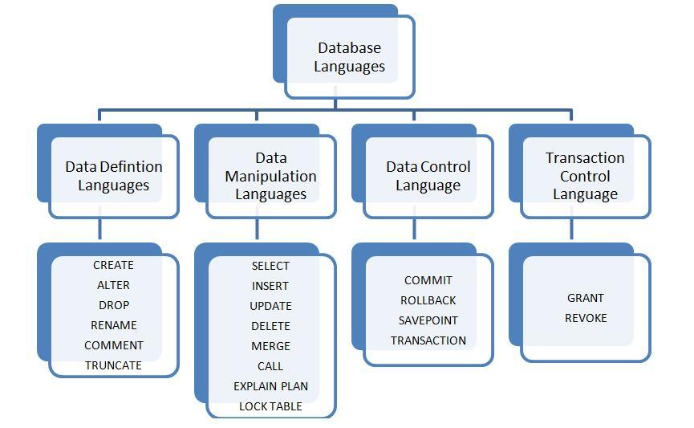

DBMS Interfaces

- Stand-alone query language interfaces
Example: Entering SQL queries at the DBMS interactive SQL interface (e.g. SQL*Plus in ORACLE)
When a DML embedded in general purpose programming model, that language is called host language and DML is called data sublanguage
- Programmer interfaces for embedding DML in programming languages
- User-friendly interfaces
- Menu-based, forms-based, graphics-based, etc.

DBMS Programming Language Interfaces

- Programmer interfaces for embedding DML in a programming languages:
  - Embedded Approach: e.g embedded SQL (for C, C++, etc.), SQLJ (for Java)
  - Procedure Call Approach: e.g. JDBC for Java, ODBC for other programming languages
  - Database Programming Language Approach: e.g. ORACLE has PL/SQL, a programming language based on SQL; language incorporates SQL and its data types as integral components

User-Friendly DBMS Interfaces

  - Menu-based, popular for browsing on the web
  - Forms-based, designed for naïve users
  - Graphics-based
  - (Point and Click, Drag and Drop, etc.)
  - Natural language: requests in written English
  - Combinations of the above:
  - For example, both menus and forms used extensively in Web database interfaces
Other DBMS Interfaces

  - Speech as Input and Output
  - Web Browser as an interface
  - Parametric interfaces, e.g., bank tellers using function keys.
  - Interfaces for the DBA:
    - Creating user accounts, granting authorizations
    - Setting system parameters
    - Changing schemas or access paths

Typical DBMS Component Modules

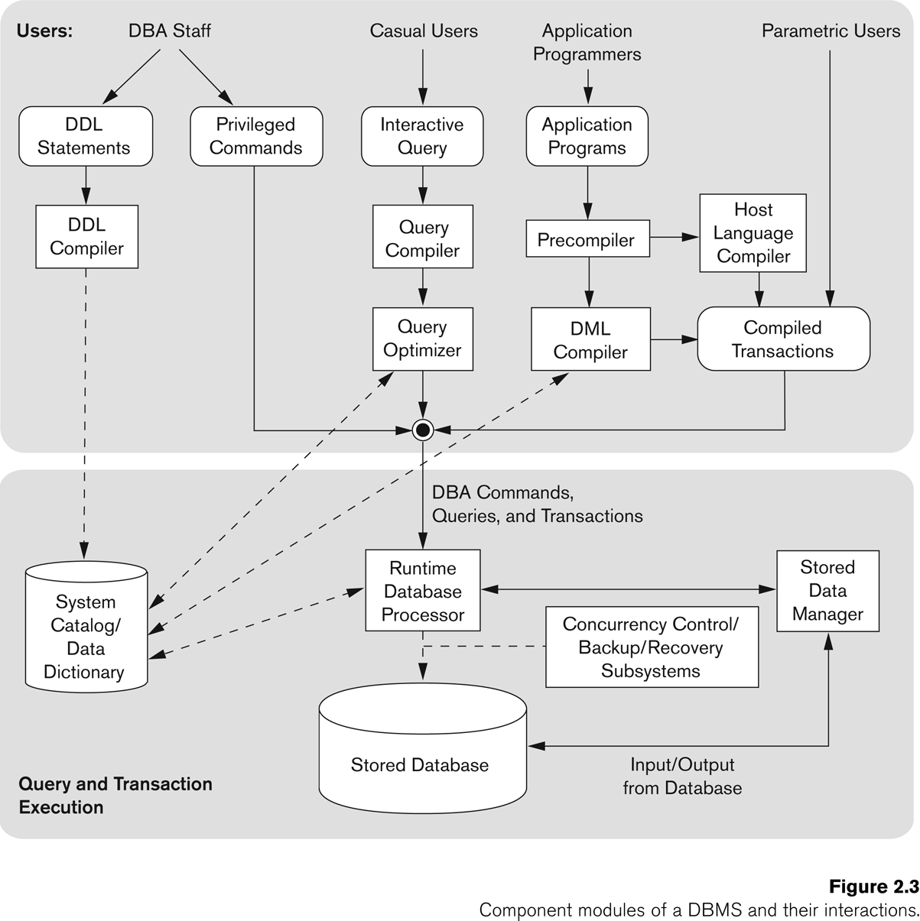

34

